AUTHENTIC MOVEMENT AND NATURE

“Morning is when I am awake and there is a dawn in me.” –Thoreau
Thoreau went to the woods to live deliberately.
We will go to the woods to dance deliberately.
The contemplative form of Authentic Movement offers us a creative means to explore our conscious and unconscious body/minds.
Nature reminds us of our place in the family of the world.
This unique day workshop will explore the interaction between Authentic Movement and nature. We will foster exploration by individuals while inviting in the collective experience of humans living in the natural world. The day will include Authentic Movement practice, a guided contemplative hike and discussion.
Come join us on June 10th from 10:30am-4:30pm at Circle Rock Retreat for a fascinating journey! Cost is $50 for the day (sliding scale available). Bring a sack lunch. Snacks and beverages will be provided.

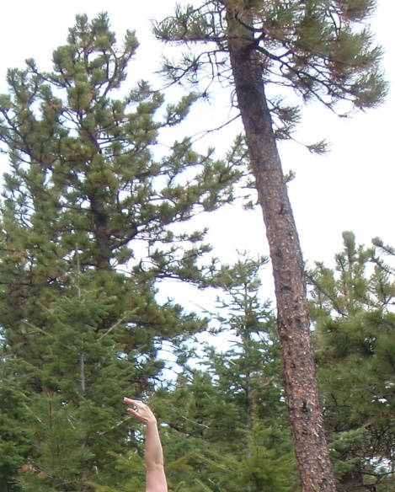

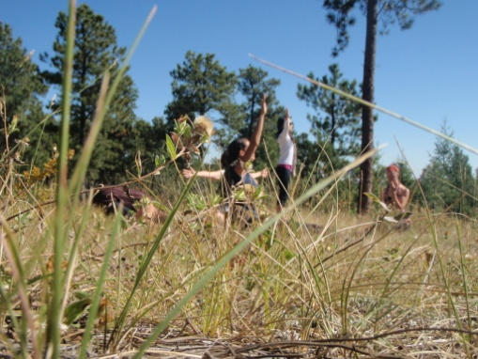

The facilitator for this workshop is Molly McLean, MA, Board Certified Dance/Movement Therapist. Molly is the owner and Director of Services for Circle Rock Retreat and a founding member of Holding Space: A Home for Authentic Movement. She has been studying Authentic Movement for 9 years, including a year-long training with Zoe Avstreih through the Center for the Study of Authentic Movement. She has been exploring her relationship with nature for her whole life, having grown up in rural Montana, amongst the trees and rocks.

Pre-registration and some experience with Authentic Movement are required.
Please contact circlerockretreat@hotmail.com or call Molly at 303-819-4046 to register and to get directions. Visit www.holdingspace.weebly.com to find out more about Holding Space: A Home for Authentic Movement and www.circlerockretreat.weebly.com to see the venue for this workshop. Inquire about carpool discounts.

